Research:

**General overview and explanation:**

Wines in this assignment are classified based on grape varietals, focusing on the South African industry. They are further organized by region, facilitating selection. Key attributes include colour (red, white, rosé), type (still, sparkling), brand, name, alcohol content, bottle weight, year of production, place of origin, and grape variety. Details describing South African and foreign wineries have also been obtained to give tourists easy access to where they can experience these wines and how they are made.

**Wine types/categories explained:**

* Red Wine: Made from grapes with tannin-releasing skins, resulting in bold flavours. Varietals include Cabernet Sauvignon, Zinfandel, Merlot, Pinot Noir, and more.
* White Wine: Produced with minimal skin contact, offering crispness and tartness. Varietals include Chardonnay, Riesling, Sauvignon Blanc, and others.
* Rosé Wine: Obtained through shorter contact with red grape skins, with lower tannin levels. Varietals include Pinot Noir, Zinfandel, Pinot Grigio, and Sangiovese.
* Dessert Wine: Sweet wines consumed after meals, with added alcohol to retain natural sugars. Varietals include Port, Madeira, Vermouth, Sherry, and Marsala.
* Sparkling Wine: Carbonated wines from natural fermentation or CO2 injection. Varietals include Champagne, Prosecco, Cava, Sparkling Rosé, Moscato, and Lambrusco.

**Wine points and prices:**

The 100-point scale is used for wine scoring, aiding consumers, and serving as a marketing tool. Scores range from 50 to 100, with 50-74 wines not recommended and scores above 94 indicating exceptional quality. Prices vary based on factors such as region, grape variety, and reputation. The pricing range for wines in South Africa varies, with affordable options priced between 50 to 100 ZAR per bottle, mid-range wines ranging from 100 to 300 ZAR, and premium/luxury wines priced at 300 ZAR and above with some wines reaching 10 000 000 ZAR. Actual prices may vary depending on factors such as winery, grape variety, region, and production methods.

**Useful information for a wine tourist:**

In South Africa, wine tourism allows visitors to explore the country's rich wine heritage through winery visits and tastings, immersing them in the production process and offering insights into the craftsmanship behind each bottle. The diverse wine varieties, including renowned varietals like Chenin Blanc and Pinotage, provide opportunities for wine enthusiasts to discover unique flavours. Wine tourism in South Africa goes beyond wine appreciation, offering cultural and historical experiences in picturesque landscapes with vineyards and landmarks. This industry plays a vital role in supporting the local economy by promoting regional development, creating employment opportunities, and stimulating related industries. The wide range of flavours found in South African wines, influenced by the diverse terroir, offers a sensory journey for wine tourists.

**References:**

1. Primer Magazine. (2022). Different Wine Types. Retrieved from <https://www.primermagazine.com/2022/learn/different-wine-types>
2. Club Vino. (n.d.). A Short Guide to the 5 Basic Characteristics of Wine. Retrieved from <https://club-vino.co.uk/a-short-guide-to-the-5-basic-characteristics-of-wine/#:~:text=These%20five%20characteristics%20are%2C%20sweetness,%2C%20tannin%2C%20alcohol%20and%20body>
3. Wine Folly. (n.d.). Wine Tourism. Retrieved from <https://winefolly.com/wine-basics/wine-tourism/>
4. ResearchGate. (n.d.). Search, experience, and credence attributes of wine. Retrieved from <https://www.researchgate.net/figure/Search-experience-and-credence-attributes-ofwine-Tabla-1-Atributos-busqueda_tbl1_235802324>
5. South African Wine. (n.d.).

Retrieved from <https://www.southafricanwine.com/>

1. Wines of South Africa. (n.d.).

Retrieved from <https://www.wosa.co.za/>

1. Wine Tourism. (n.d.).

Retrieved from <https://winefolly.com/wine-basics/wine-tourism/>

1. Hall, C. M., Sharples, L., Mitchell, R., Macionis, N., & Cambourne, B. (2015). Wine tourism in South Africa. In Wine and Tourism: A Strategic Segment for Sustainable Economic Development (pp. 199-214). Channel View Publications.

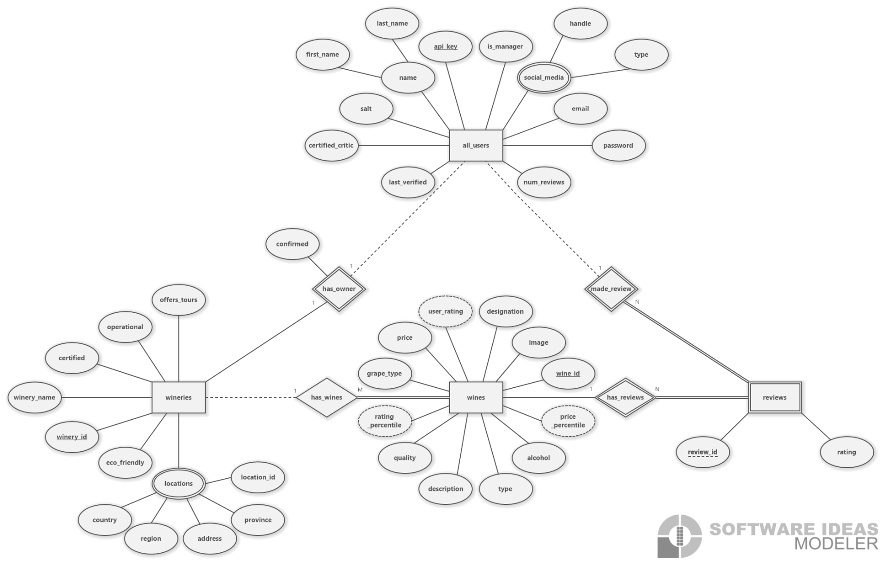(E)ER-Diagram:

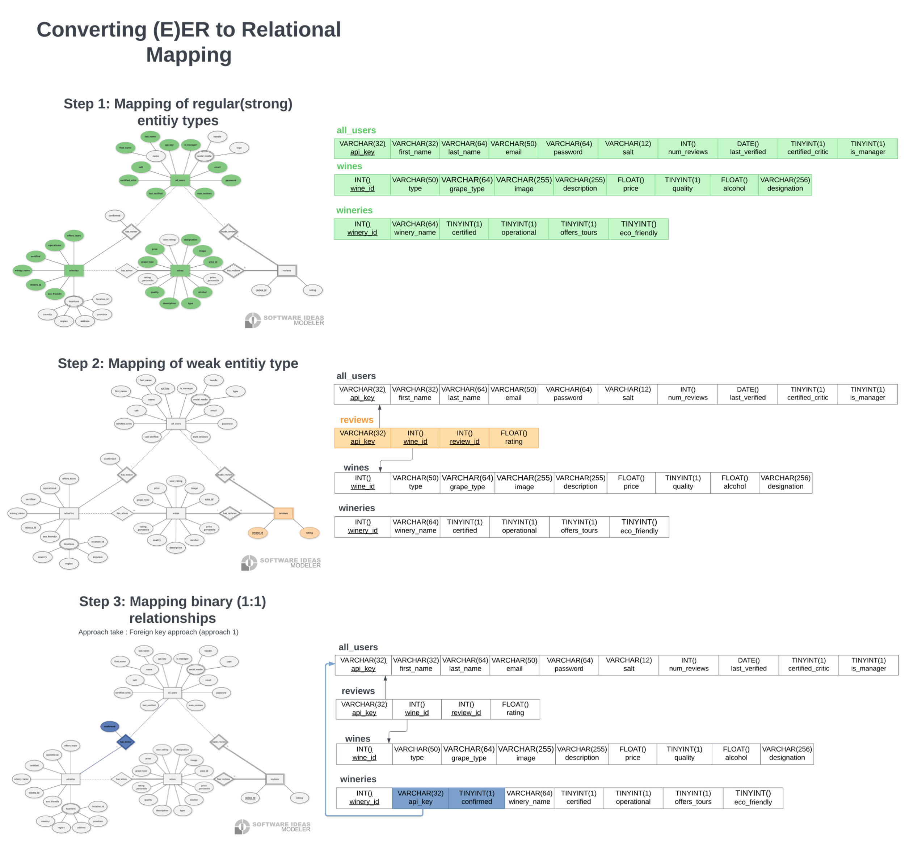Mapping:

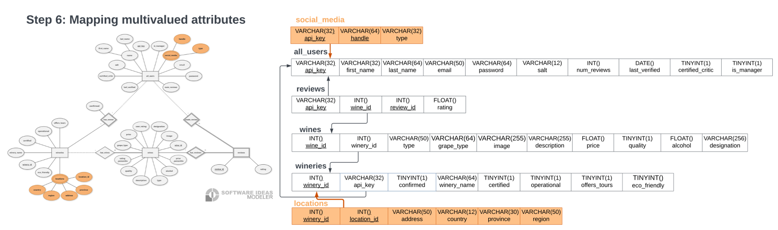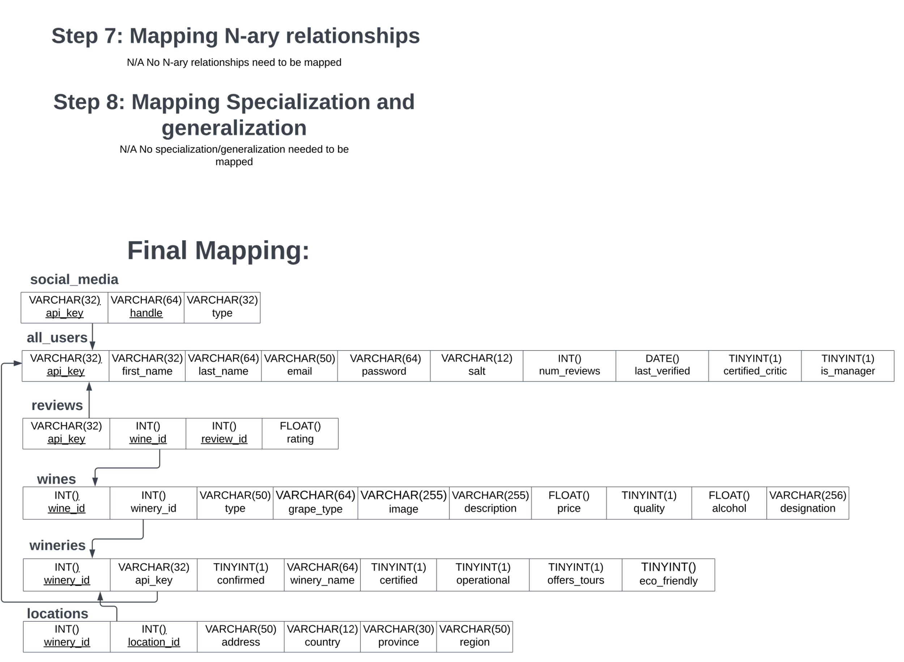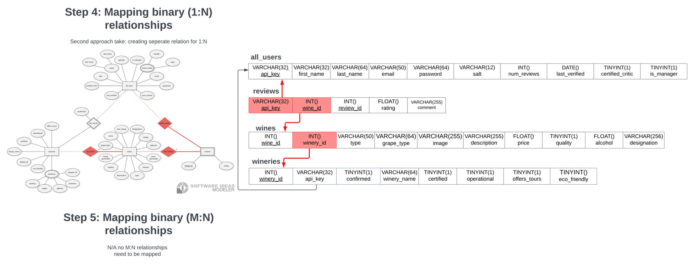

**Data types and explanation:**

ENTITIES:

wines:

* Wine_id : Primary key; Identifier for the wines; (INT())
* image : wine image (url) (VARCHAR(255))
* Price: the price of the specific wine (FLOAT())
* User_rating: derived attribute of the average of all the user ratings of this wine (FLOAT())
* Quality: critics (using 100-point scale) rating of a wine (entry example: 92) (INT())
* Alcohol: % alcohol of the wine (FLOAT())
* Rating_percentile: derived attribute, position this wine falls in compared to all other wines (as a %, for example 1% means top 1%, 100% means worst of the worst) (INT())
* Grape_type: type of grape used for the wine (for example Merlot)(VARCHAR(64))
* Type: Type of wine (for example red wine) (VARCHAR(50))
* Price_percentile: derived attribute, position this wine falls in compared to all other wines’ price (as a %, for example 1% means top 1% most expensive, 100% means worst of the worst dirt cheap)(INT())
* Description: description of the wine (VARCHAR(1024))
* Designation: combination of type and name of wine (VARCHAR(255))

All_users:

* Last_verified: The date that the account was last verified (user emails should be verified every 6 months) (DATE())
* Cerified_critic: states whether or not the user is a certified critic (their reviews get displayed separately)(TINYINT(1))
* Name: composite attribute; name of user made from (first_name(VARCHAR(32)) and last_name(VARCHAR(64))
* Api_key: uniquely generated primary key (VARCHAR(32))
* Email: user email address (VARCHAR(50))
* Social media: multivalued composite attribute (made from : handle(VARCHAR(64)) and type(VARCHAR(32))
* Password: hashed user password (VARCHAR(64))
* Salt: salt for the password (VARCHAR(12))
* Num_reviews: number of reviews that user has made (INT())
* Is_manager: states whether or not they are a manager (TINYINT(1))

Wineries:

* Offers_tours: do they offer tours? (TINYINT(1))
* Operational: Are they operational right now? (TINYINT(1))
* Certified: are they certified? (TINYINT(1))
* Winery_name: the name of the winery (VARCHAR(64))
* Winery_id: Primary key; the uniquely generated id for the winery (INT())
* Eco_friendly: certified to be eco-friendly (TINYINT(1))
* Locations; multivalued attribute containing: (Country: VARCHAR(12)
  + Region: VARCHAR(50)
  + Province: VARCHAR(30)
  + Location_id: PK for each location uniquely generated (INT()))
  + address: Address of the winery (VARCHAR(50))

Reviews:

* Review_id: Primary key; weak key for reviews, uniquely generated (INT())
* Rating: rating from 0 to 5 stars that the user gave the wine (FLOAT())

RELATIONSHIPS:

Has_owner (1 to 1 mapping where one user optionally owns one winery):

* Confirmed: is a confirmed owner (TINYINT(1))
* Api_key from the user that is the owner
* Winery_id from the winery that that user owns

Made_review (1 to many mapping where one user can make many reviews):

* Api_key of user that made the review
* Review_id of the review that was made

(each user can only review a single wine once (meaning they can not review the same wine twice))

Has_reviews (1 to many mapping where one wine can have many reviews):

* Wine_id of the wine that was reviewed.
* Review_id of the review.

Has_wines (1 to many mapping where one winery can have many wines):

* Winery_id
* Wine_id

Relational Schema

Checks, Keys and Domains

social_media

api_key must exist in all_users (foreign key)

handle: NOT NULL

type: NOT NULL

handle and type: string > 0

index on api_key and handle (composite key)

all_users

api_key is auto_generated using trigger: NEW.api_key = REPLACE(MD5(UUID()), "-", "")

first_name: NOT NULL

last_name: NOT NULL

email: unique (secondary key), NOT NULL

password: unique, NOT NULL

salt: unique, NOT NULL

num_reviews: calculated by database

last_verified: set by web admin, default NOW

certified_critic: set by web admin, default FALSE

is_manager: default FALSE

all strings > 0

reviews

api_key must exist in all_users (foreign key)

wine_id must exist in wines (foreign key)

review_id: auto-incremented, NOT NULL

rating: domain [0.0,5.0] NOT NULL

primary key on api_key, wine_id and review_id (composite key)

wines

wine_id: auto-incremented

winery_id must exist in wineries (foreign key)

type: string > 0, default "other"

grape_type: string > 0, NOT NULL

image: can be null, if no image exists. else, string > 0

description: NOT NULL, string > 0

price: converted to ZAR, NOT NULL, default 0

quality: NOT NULL, value > 0

alcohol: decimal percentage, NOT NULL

designation: NOT NULL, string > 0

rating_percentile: calculated using trigger

price_percentile: calculated using trigger

percentiles are calculated as "n = (P/100) x N, where P = percentile, N = number of values in a data set (sorted from smallest to largest), and n = ordinal rank of a given value."

index on winery_id, grape_type and designation (composite and alternate key)

wineries

winery_id: auto-incremented

api_key must exist in all_users (foreign key)

confirmed: default FALSE, set by web admin

winery_name: NOT NULL, string > 0

certified: default FALSE, set by web admin

operational: default FALSE, set by web admin

offers_tours: default FALSE

eco_friendly: default FALSE

locations

winery_id must exist in wineries (foreign key)

location_id: auto-increment

country: NOT NULL, string > 0

province: NOT NULL, string > 0

region: NOT NULL, string > 0

index on country, province and region (composite and alternate key)

Additional checks, constraints

nullable columns:

wines.image

specific lengths:

all_users.salt must be length 12

all other strings must not exceed the data type length

foreign keys

all foreign keys are checked on update operations

Cascading deletes

* Social media information is deleted if the associated user is deleted
* Reviews are deleted if their associated wine or user is deleted
* Wines are deleted if their winery is deleted

Triggers

* Generating the api_key as a 32bit random unique string
* Updating the new_reviews on any update to the reviews table
* Calculating percentiles in the wines table

Example

DELIMITER //

CREATE TRIGGER set_api_key

BEFORE INSERT ON all_users

FOR EACH ROW

BEGIN

SET NEW.api_key = REPLACE(MD5(UUID()), "-", "");

END//

DELIMITER ;